EXERCISE 6: LIBRARY MANAGEMENT SYSTEM

Name: Shubham Sangram Bej
AIM
To implement Linear Search and Binary Search algorithms for searching books in a Library Management System and compare their performance.
INTRODUCTION
Searching is the process of finding a specific element within a collection of data. Efficient searching techniques improve the performance of applications that manage large datasets.
SEARCH ALGORITHMS
- Linear Search
Linear Search examines each element sequentially until the required element is found.
Steps:
• Start from the first element.
• Compare each element with the target.
• Stop when a match is found, or the list ends.
Advantages:
• Simple to implement.
• Works on both sorted and unsorted data.
Disadvantages:
• Slow for large datasets.
Time Complexity:
- Best Case: O(1)
- Average Case: O(n)
- Worst Case: O(n)

- Binary Search
Binary Search repeatedly divides the search space into two halves.
Requirements:
• Data must be sorted.
Steps:
• Find the middle element.
• Compare with the target value.
• Search the left half or the right half accordingly.
• Repeat until the element is found.
Advantages:
• Very fast for large datasets.
• Efficient searching technique.
Disadvantages:
• Requires sorted data.
Time Complexity:
- Best Case: O(1)
- Average Case: O(log n)
- Worst Case: O(log n)
BOOK CLASS
The Book class contains:
• Book ID
• Title
• Author
IMPLEMENTATION
The Library Management System performs:
- Linear Search
Books are searched sequentially by title.
- Binary Search
Books are first sorted alphabetically and then searched using Binary Search.
- Performance Comparison
Execution times of both algorithms are measured using System.nanoTime().

TIME COMPLEXITY COMPARISON
Linear Search
- Best Case: O(1)
- Average Case: O(n)
- Worst Case: O(n)
Binary Search
- Best Case: O(1)
- Average Case: O(log n)
- Worst Case: O(log n)
WHEN TO USE EACH ALGORITHM
Use Linear Search:
• Small datasets
• Unsorted data
• Simple applications
Use Binary Search:
• Large datasets
• Sorted data
• Performance-critical systems
OBSERVATION
Binary Search performs significantly faster than Linear Search when the dataset is sorted.
OUTPUT
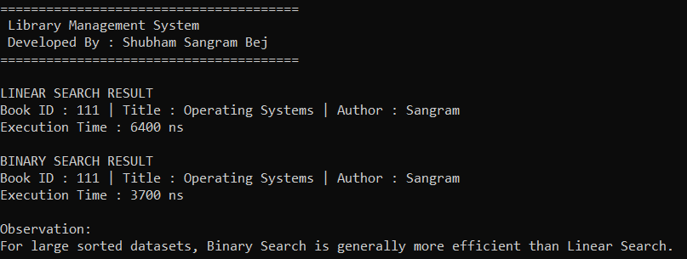

RESULT
The Library Management System was successfully implemented using Linear Search and Binary Search techniques.
CONCLUSION
The experiment demonstrated that Binary Search is more efficient than Linear Search for large sorted datasets. Linear Search is useful for small or unsorted datasets, whereas Binary Search is preferred when faster searching is required.

